School Name
Mathematics Test 2017
Year 10 |  | Financial Maths & Compound Interest | Calculator  Allowed
Skills and Knowledge Assessed:  - Complete calculations related to making financial decisions.  - Solve problems involving simple interest (ACMNA211)  - Connect the compound interest formula to repeated applications of simple interest using appropriate digital technologies (ACMNA229) |  |  | Name_________________
Section 1 Short Answer Section
Write all working and answers in the spaces provided on this test paper.

Compound Interest
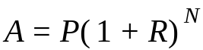
A is the total amount of the investment
P is the principal
R is the interest rate per period as a decimal
N is the number of compounding periods
Simple Interest

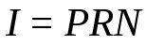
I is the interest earned
P is the principal
R is the interest rate per period as a decimal
N is the number of periods

Gina invests $800 for 4 years at 7% p.a. simple interest. How much interest will she earn?

……………………………………………………………………………………………….

……………………………………………………………………………………………….
Michael invests $3500 for 4 years and earns $1260 in simple interest. What annual rate was paid on her investment?

……………………………………………………………………………………………….

……………………………………………………………………………………………….
Meredith bought a tablet which had a cash price of $750, by paying monthly instalments of $40 for 2 years. How much did he pay in interest?

……………………………………………………………………………………………….

……………………………………………………………………………………………….
Questions 4 and 5 refer to the table below which gives the value of $1.00 after being invested at different rates of compound interest for varying terms.

 | Compound interest rate p.a.
Years  Invested | 2% | 3% | 4% | 5% | 6% | 7% | 8%
1 | 1.0200 | 1.0300 | 1.0400 | 1.0500 | 1.0600 | 1.0700 | 1.0800
2 | 1.0404 | 1.0609 | 1.0816 | 1.1025 | 1.1236 | 1.1449 | 1.1664
3 | 1.0612 | 1.0927 | 1.1249 | 1.1576 | 1.1910 | 1.2250 | 1.2597
4 | 1.0824 | 1.1255 | 1.1699 | 1.2155 | 1.2625 | 1.3108 | 1.3605
5 | 1.1041 | 1.1593 | 1.2167 | 1.2763 | 1.3382 | 1.4026 | 1.4693
6 | 1.1262 | 1.1941 | 1.2653 | 1.3401 | 1.4185 | 1.5007 | 1.5869

A principal of $6500 is invested at 5% pa interest compounded annually. Find the value of the investment after 3 years.

……………………………………………………………………………………………….

……………………………………………………………………………………………….
An amount of money which is invested at 7% pa interest compounded annually is worth $9800 after 6 years. Find the amount that was invested (to the nearest ten dollars)?

……………………………………………………………………………………………….

……………………………………………………………………………………………….
Questions 6 and 7 refer to an investment of $7500 with interest at 5% p.a. compounded annually.
(You may also refer to the table above)
How much interest is earned after 5 years?

……………………………………………………………………………………………….

……………………………………………………………………………………………….

……………………………………………………………………………………………….
How much interest is earned in the 6th year?

……………………………………………………………………………………………….

……………………………………………………………………………………………….

……………………………………………………………………………………………….
Use the compound interest formula to find the value of $12 000 invested at 7% p.a., compounding annually for 4 years.

……………………………………………………………………………………………….

……………………………………………………………………………………………….

……………………………………………………………………………………………….
Graham invests $4800 at 12% p.a. compounding monthly.
What is the value of the investment after 2 years?

……………………………………………………………………………………………….

……………………………………………………………………………………………….

……………………………………………………………………………………………….
Five years ago, Vicki bought a tractor for her farm for $88 000 and it has depreciated at 9% p.a. over that time. What is its current value (to the nearest dollar)?

………………………………………………………………………………………………

……………………………………………………………………………………………….

……………………………………………………………………………………………….
Three and a half years ago, Jeff invested $45 000 in a term deposit paying interest at 9% p.a. compounded half-yearly. What is the current value of the investment?

……………………………………………………………………………………………….

……………………………………………………………………………………………….

……………………………………………………………………………………………….

……………………………………………………………………………………………….
Eighteen months ago, Toby invested $28 000 in an account that paid 6.4% p.a. compounding quarterly. How much interest did he earn?

……………………………………………………………………………………………….

……………………………………………………………………………………………….

……………………………………………………………………………………………….
Five years ago, Zaahir invested some of money in an account that paid 5.4 % p.a. compounding quarterly. The account is now worth $69 800. How much was in the account initially?

……………………………………………………………………………………………….

……………………………………………………………………………………………….

……………………………………………………………………………………………….

……………………………………………………………………………………………….
Quentin has $60 000 to invest in an account paying 8% pa and he wants it to grow to $75 000.
If the interest is compounded annually, determine the time (to the nearest month) that he must leave the funds in the account to achieve his aim? (You will need to use guess and check.)

……………………………………………………………………………………………….

……………………………………………………………………………………………….

……………………………………………………………………………………………….

……………………………………………………………………………………………….
A tourist business bought a minibus 4 years ago. It has depreciated at 12% p.a. since then. Its current value is $64 800. What was its value when it was new (to the nearest $50)?

……………………………………………………………………………………………….

……………………………………………………………………………………………….

……………………………………………………………………………………………….

……………………………………………………………………………………………….

School Name
Mathematics Test 2017
Year 10 |  | Financial Maths & Compound Interest | Calculator Allowed
 |  | Financial Maths & Compound Interest | Name_________________
Section 2 Multiple Choice Section
Mark all your answers on the accompanying multiple choice answer sheet, not on this test paper. You may do any working out on this test paper. Calculators are allowed for this section.

Yvette bought a lounge suite which was originally priced at $2450 at a sale which offered her a discount of 30%. She also had to pay a delivery fee of $24.00.
What did she pay altogether to get the lounge suite home?

A. $1698.20 B. $1715.00 C. $1731.80 D. $1739.00
Max bought a new guitar by paying a deposit of $80.00 and making 52 weekly payments of $30.00. The cash price for the guitar was $1350.00.
How much extra did he pay by choosing the pay off the guitar?

A. $210 B. $290 C. $370 D. $1640
Questions 3 and 4 refer to the following:
Xia invests $5000 in an account which pays 12% p.a. interest, compounded annually.
He created a spreadsheet, part of which is shown below to show the progress of the investment.
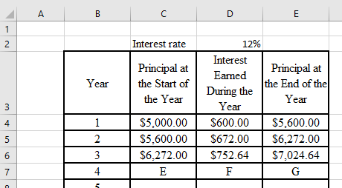
What number should appear at position F (cell D7)?

A. $833.28 B. $839.55 C. $842.96 D. $7024.64
What number should appear at position G (cell E7)?

A. $7024.64 B. $7857.92 C. $7864.19 D. $7867.60
Use the compound interest formula to calculate the value of an investment of $1200, at 7% p.a. compounding annually for 6 years.

A. $1800.88 B. $1851.96 C. $1962.94 D. $2056.59
Ngaire borrows $6000 from her brother and repays the full amount plus interest after 3 years. Her brother charges interest at 8% p.a. compounded quarterly. How much does she need to repay?

A. $7558.27 B. $7591.91 C. $7609.45 D. $8075.21
Valerie invested $3500 in a term deposit for 5 years. The interest rate is 7.5% p.a. compounded annually. How much interest will Summer have earned at the end of the 5 years?

A. $1524.70 B. $1557.65 C. $1586.53 D. $5024.70
Owen deposits $9000 into a term deposit and makes no deposits or withdrawals for 3½ years. The account pays 6% p.a. interest compounded monthly. How much will be in his account at the end of the time?

A. $11 036.03 B. $11 097.29 C. $11 434.40 D. $18 122.45
Five years ago, Ulrich bought car for his company for $45 000. Since then the car has depreciated at 14% p.a.
What is its value now?

A. $31 500 B. $21 779 C. $21 169 D. $13 500
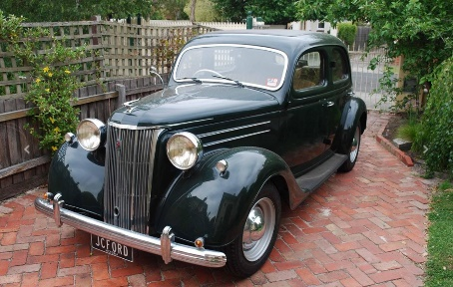
Priya buys a vintage car on terms over 4 years and pays $609 per month. If the cash price of the car was $22 500, what rate of simple interest did she pay, per annum?
A. 4.5% B. 5.5%
C. 6.5% D. 7.5%
Tex wants to buy a trail-bike which has a cash price of $12 500.00. It can also be bought on a 4-year monthly payment plan. If they charge 15% p.a. simple interest for those buying on the plan, how much is each monthly payment?

A. $156.25 B. $416.67 C. $425.50 D. $833.33
Sigrid deposits $58 000 into an account that earns interest at the rate of 6.6% p.a. compounding monthly. How much will be in the account after 2½ years if he makes no deposits or withdrawals in that time?

A. $68 373.88 B. $68 389.31 C. $71 125.66 D. $71 234.99
Which calculation would you use to find the amount that $40 000 grows to when invested at 9.6% p.a. interest compounding six-monthly for 6 years.
A. 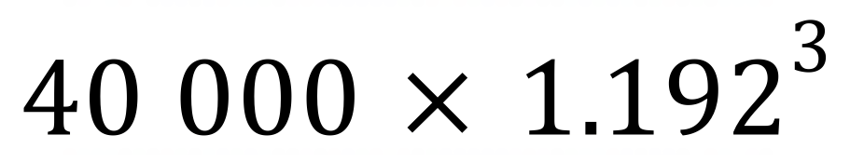 B. 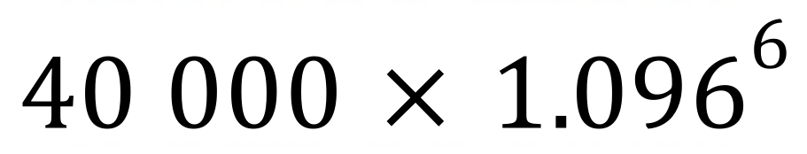
C. 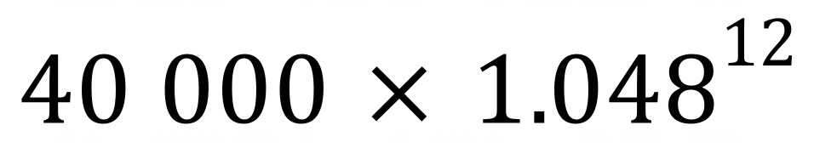 D. 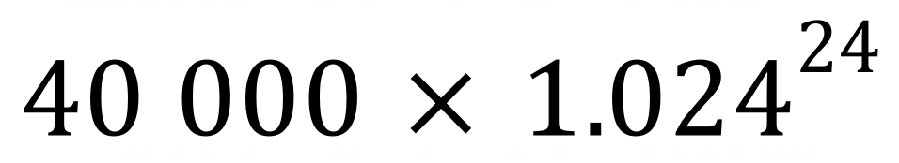
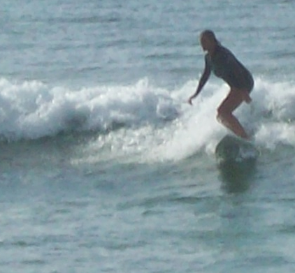
Rosalyn bought a surf board 3 years ago. It depreciated at 18% p.a. and is now worth $360
What was its original value?
A. $554
B. $591
C. $597
D. $653
Keira invested $6000 an account that paid 15% p.a. compounding monthly. The account is now worth $11 447.03. How long was the money invested for?

A. 4 years and 2 months B. 4 years and 4 months
C. 4 years and 6 months D. 4 years and 8 months

School Name
Mathematics 2017
Multiple Choice Answer Sheet
Financial Maths & Compound Interest
Name _____________________________________________
Completely fill the response oval representing the most correct answer.
1. A B C D
2. A B C D
3. A B C D
4. A B C D
5. A B C D
6. A B C D
7. A B C D
8. A B C D
9. A B C D
10. A B C D
11. A B C D
12. A B C D
13. A B C D
14. A B C D
15. A B C D

School Name
Mathematics Test 2017
Year 10 | Financial Maths & Compound Interest | Short Answer Section
ANSWERS

Question | Working and Answer
 | 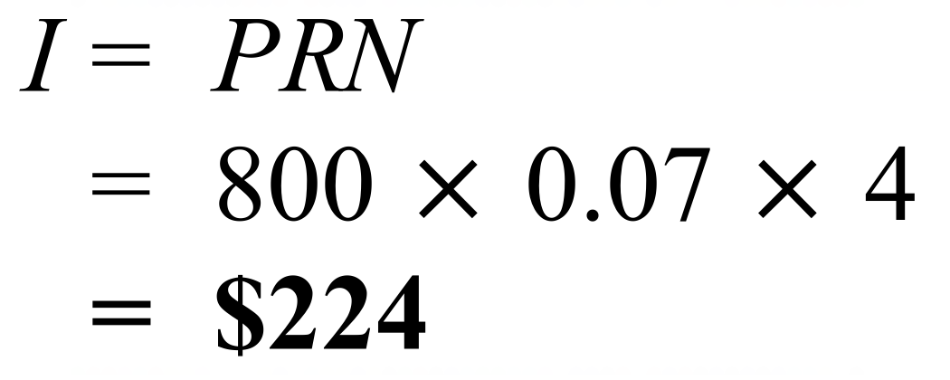
 | 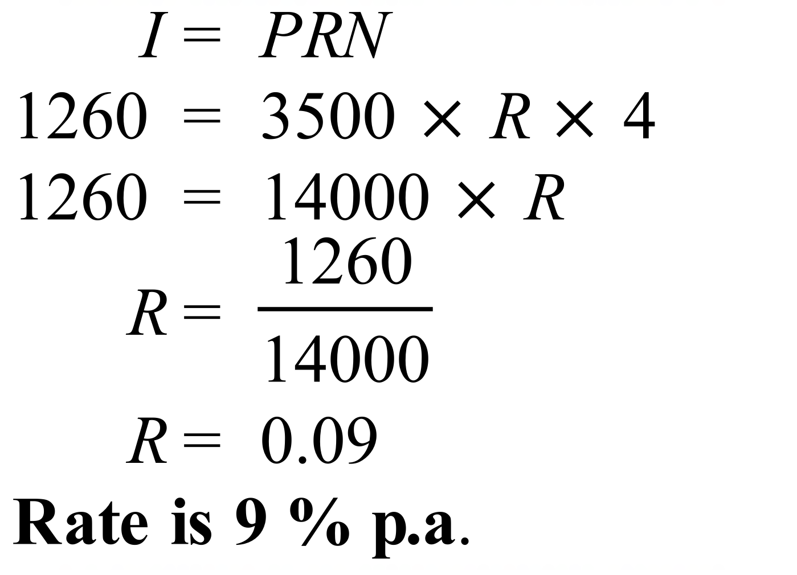
 | 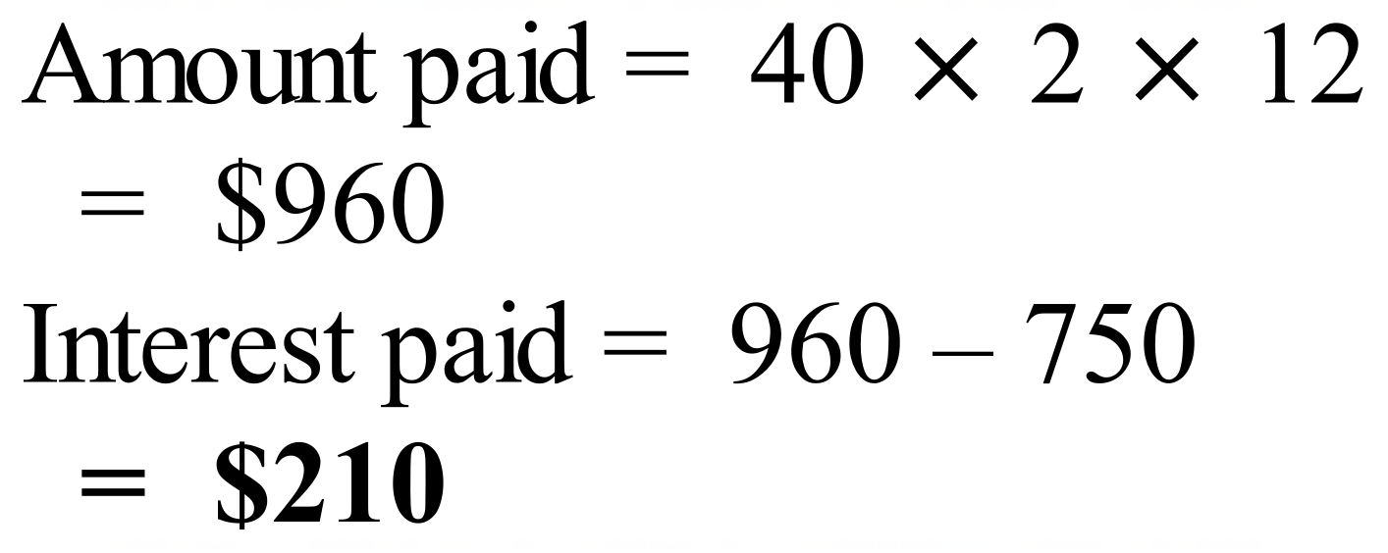
 | 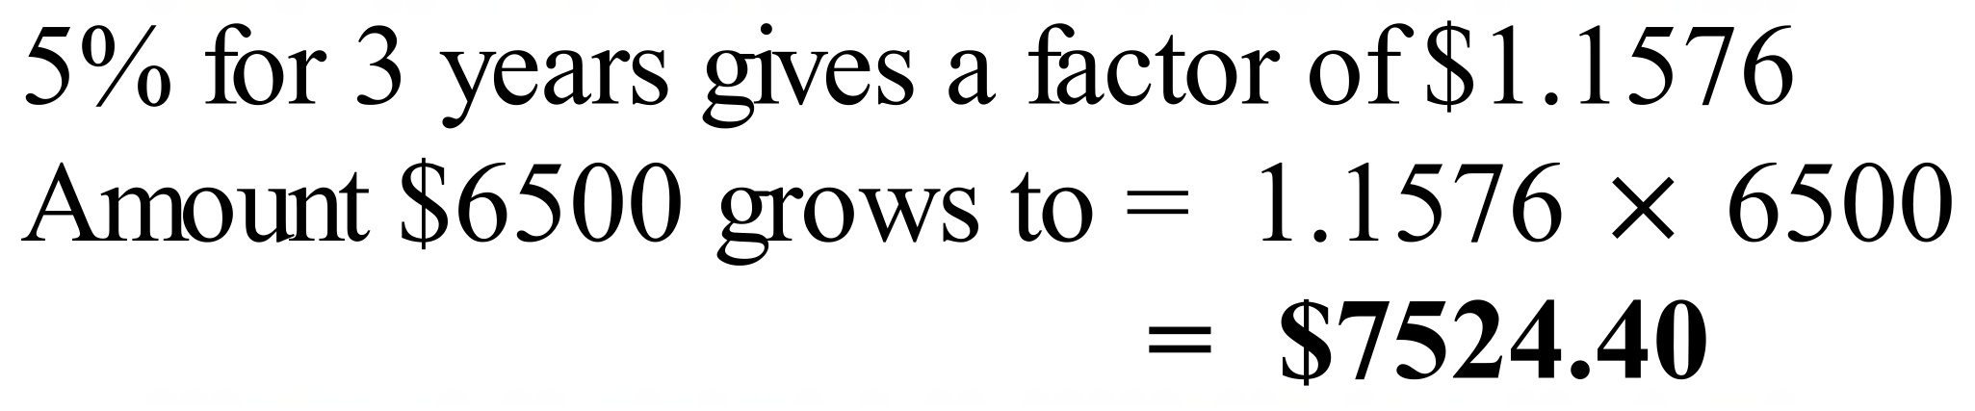
 | 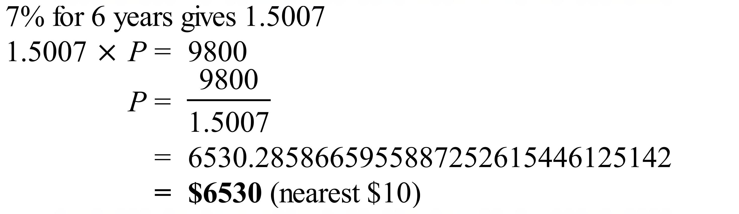
 | 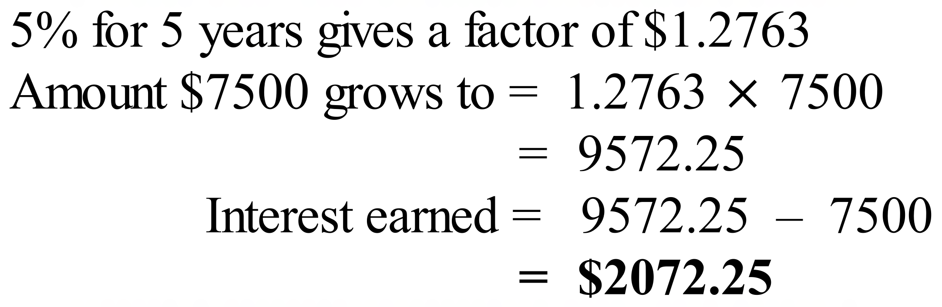
 | 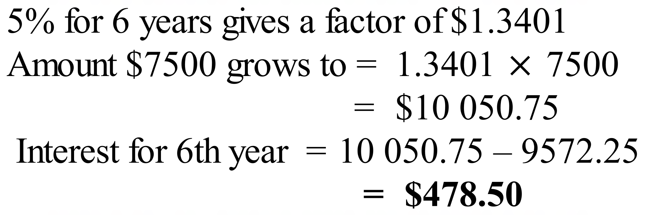
 | 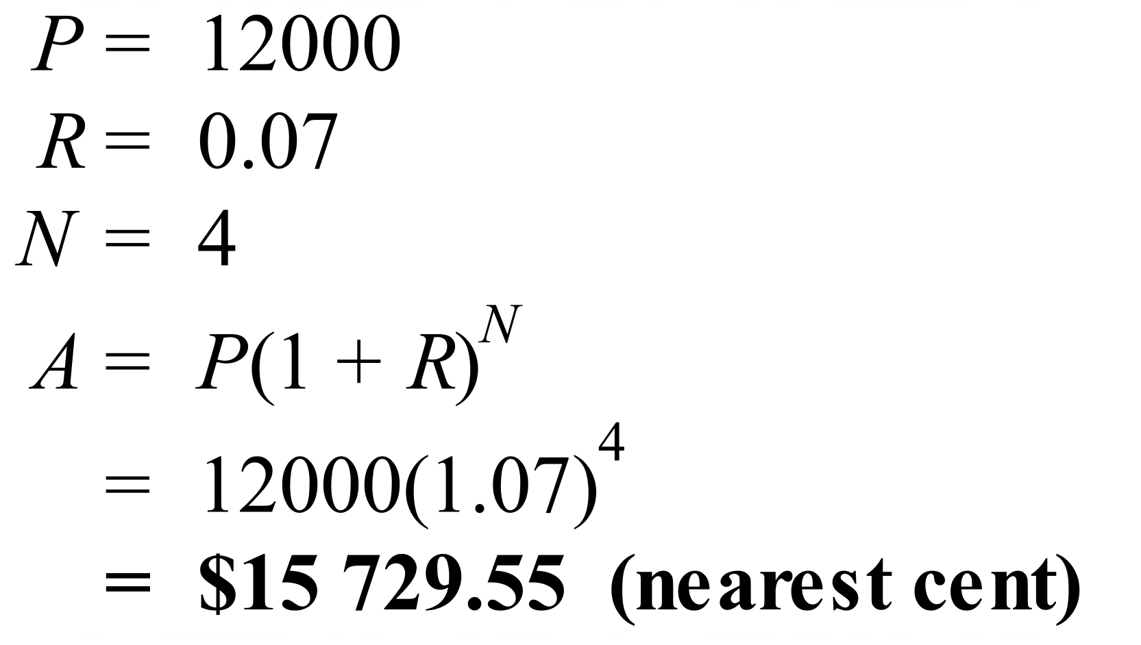
 | 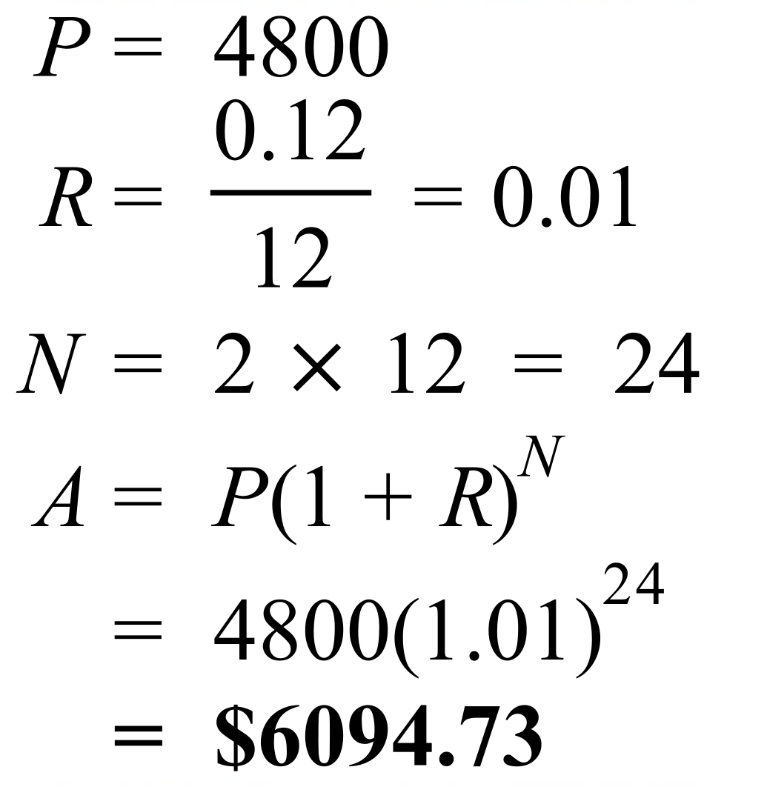
 | 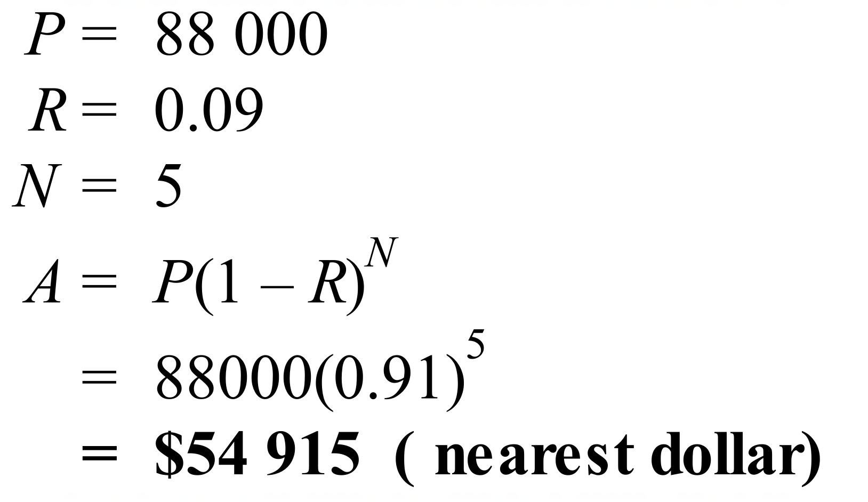
 | 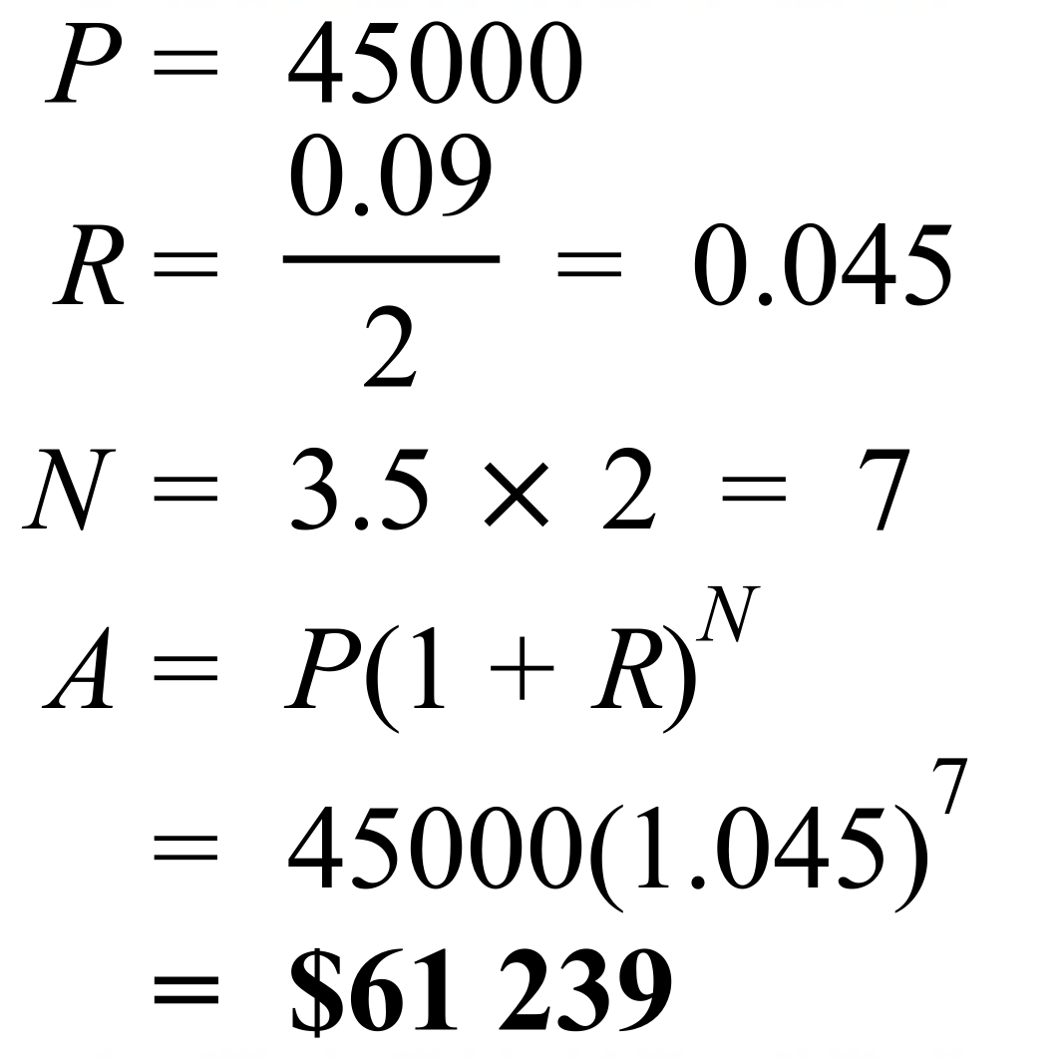
 | 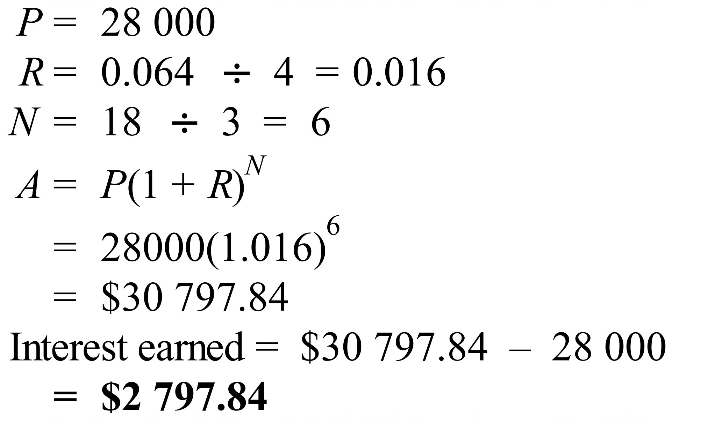
 | 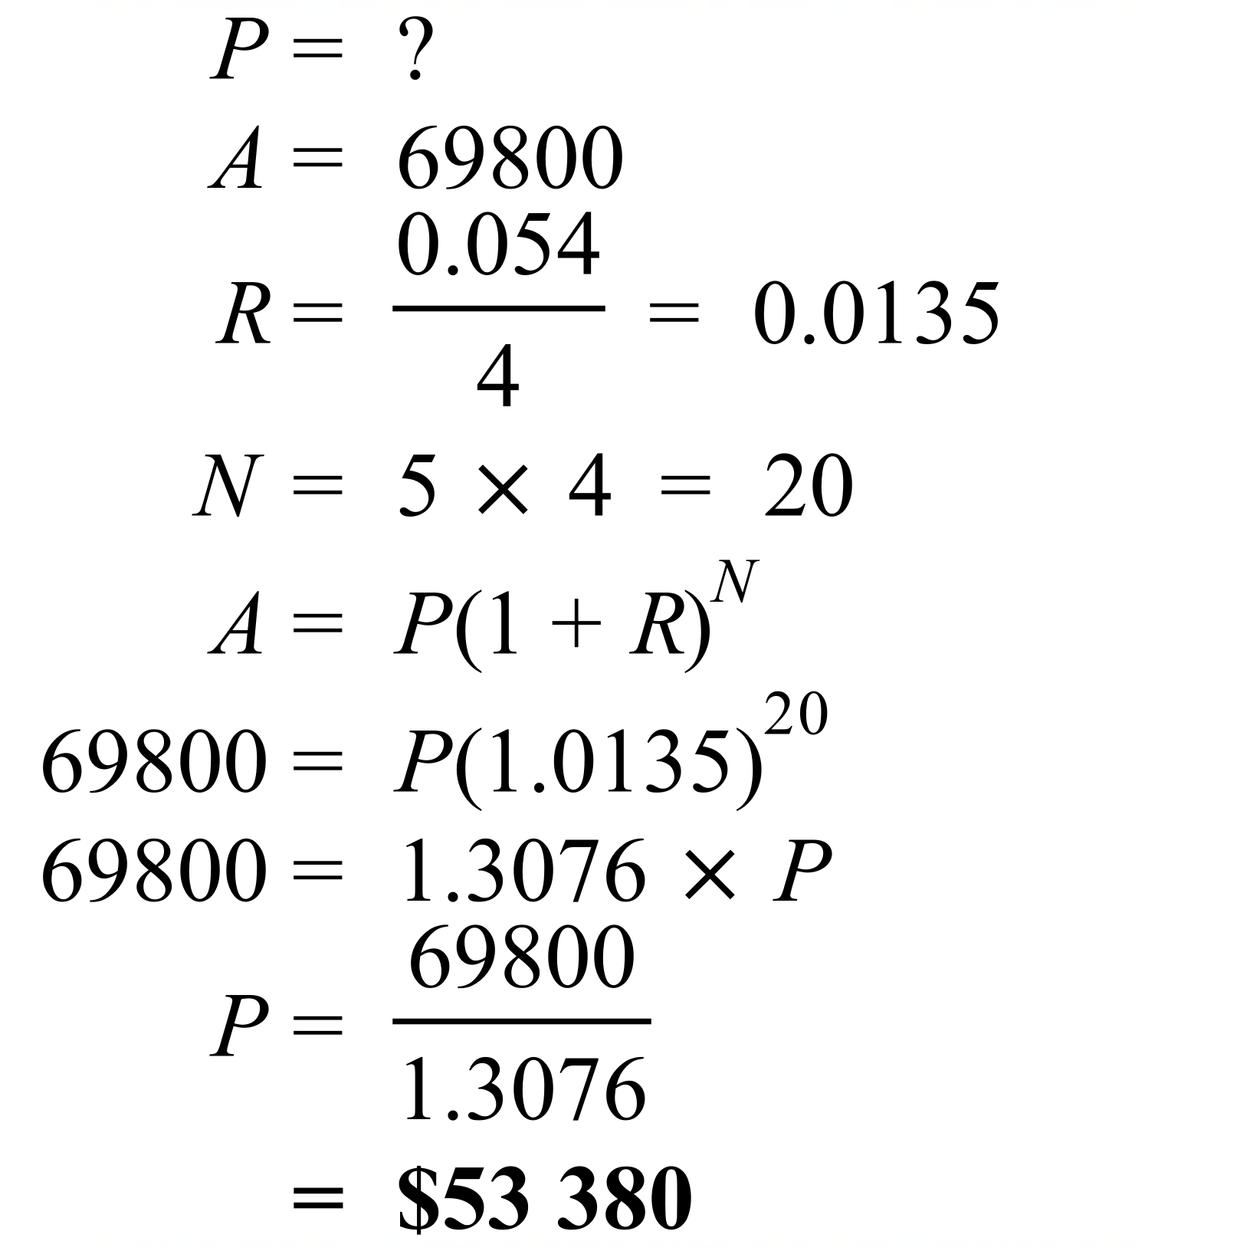
 | 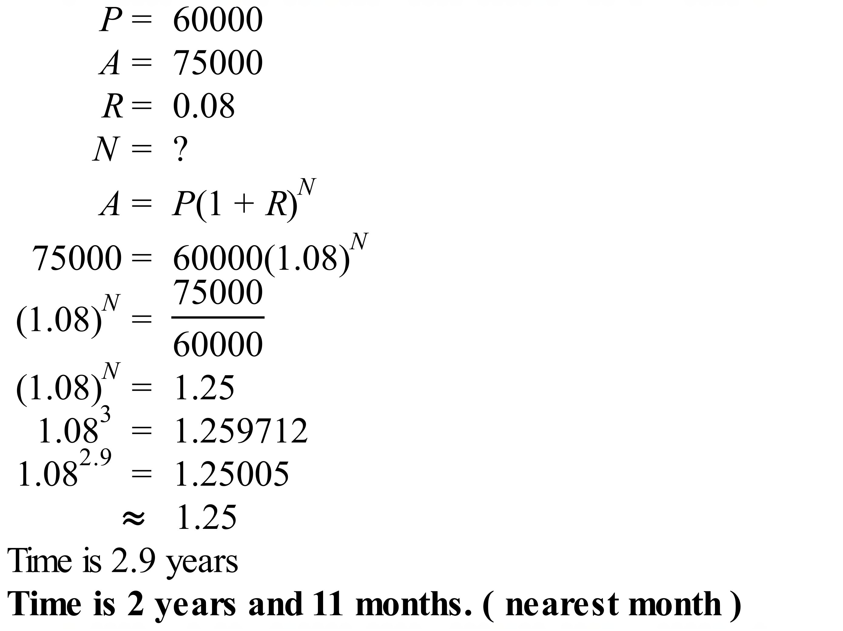
 | 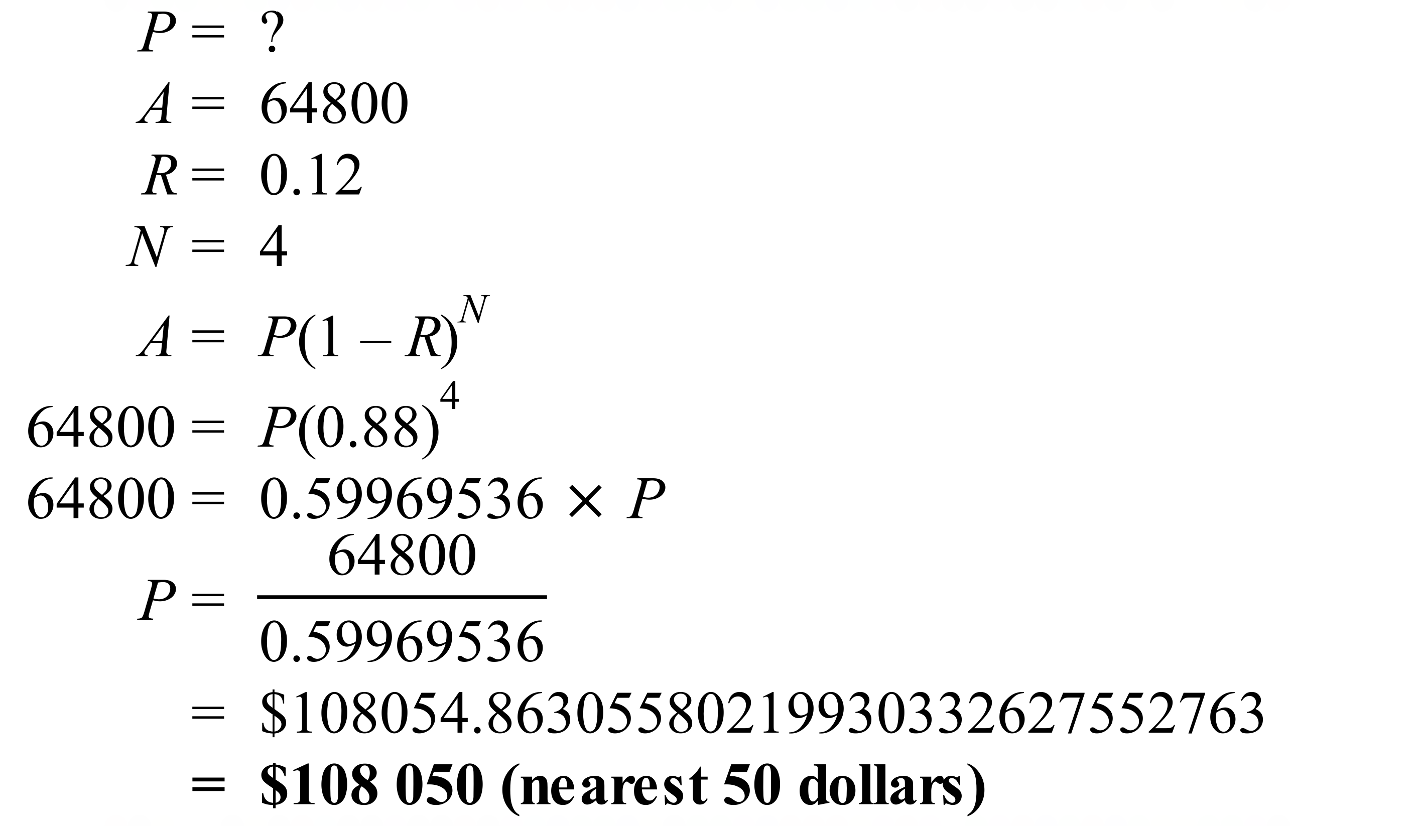

School Name
Mathematics Test 2017
Year 10 | Financial Maths & Compound Interest | Calculator Allowed  Multiple Choice  Section

ANSWERS

Question | Working | M C Answer
 | 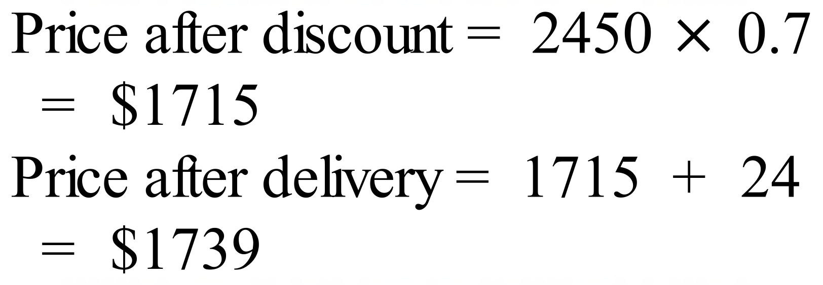 | D
 | 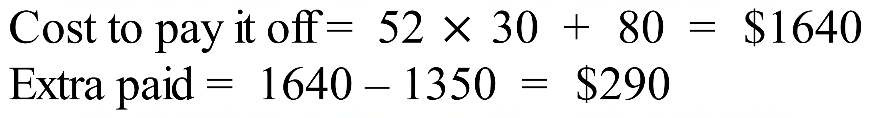 | B
 |  | C
  3 | $6,272.00 | $752.64 | $7,024.64
  4 | E = $7,024.64 | F = $842.96 | G = $7,867.60
 |  | D
 | 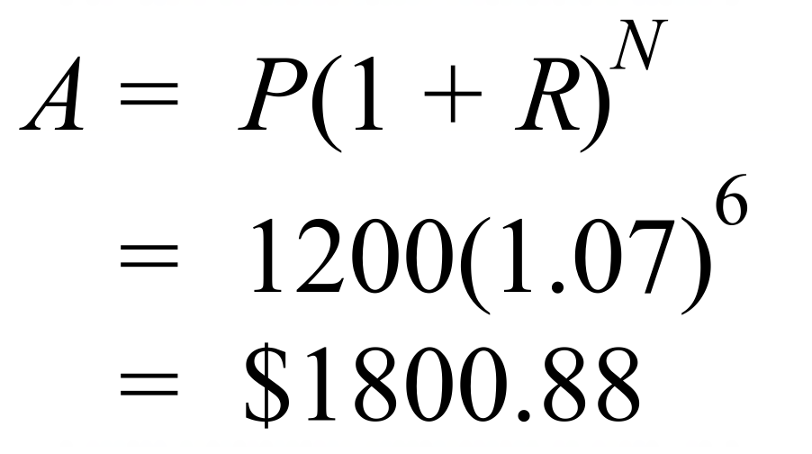 | A
 | 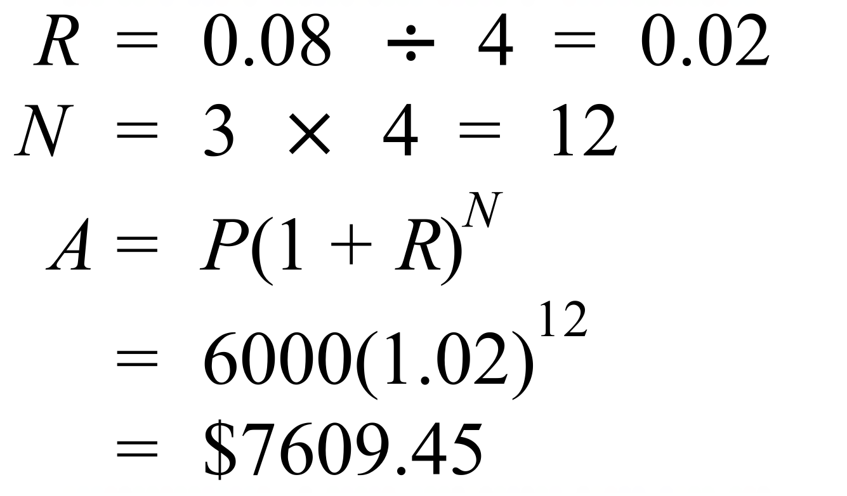 | C
 | 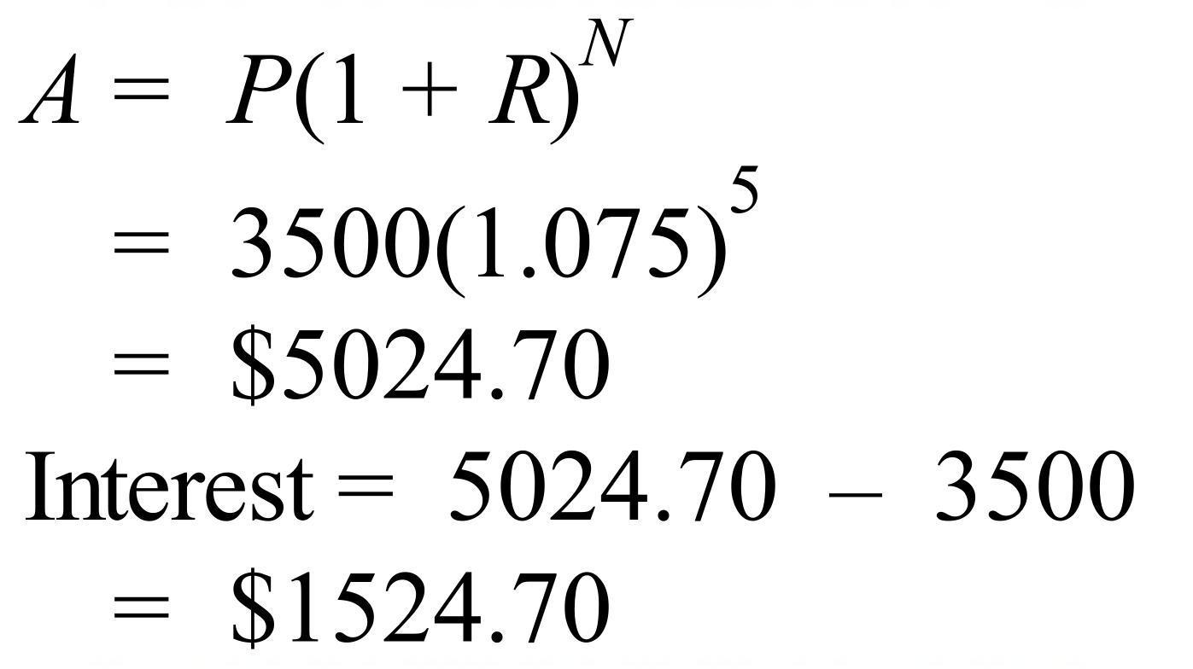 | A
 | 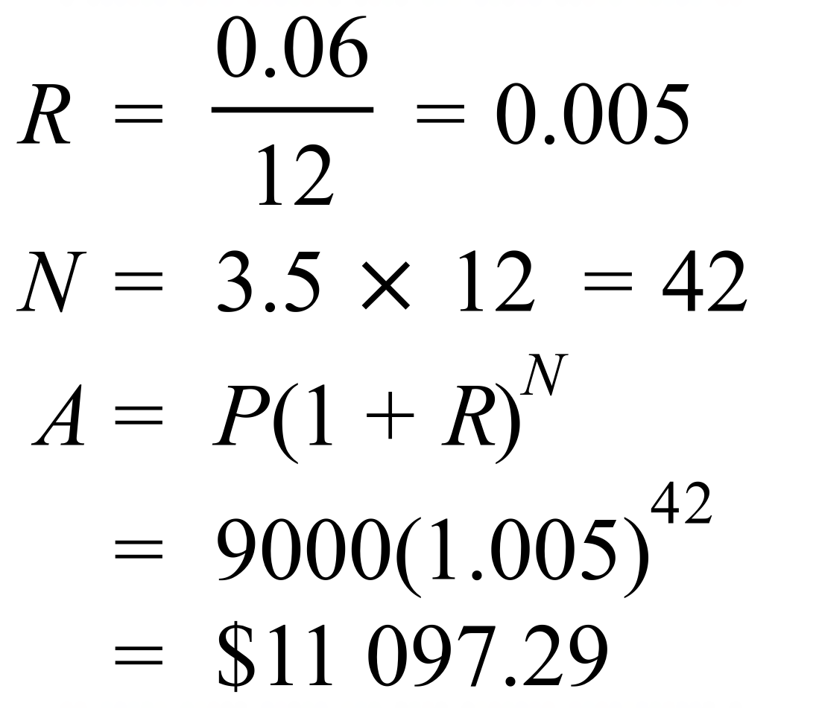 | B
 | 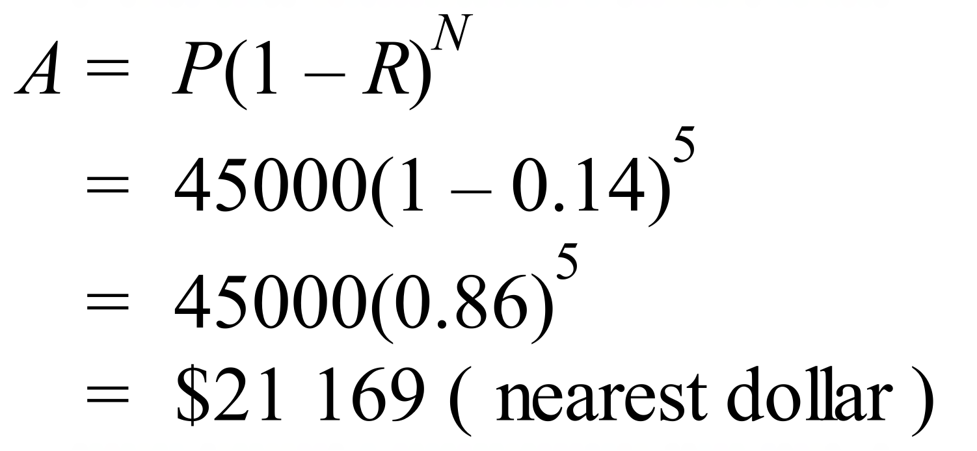 | C
 | 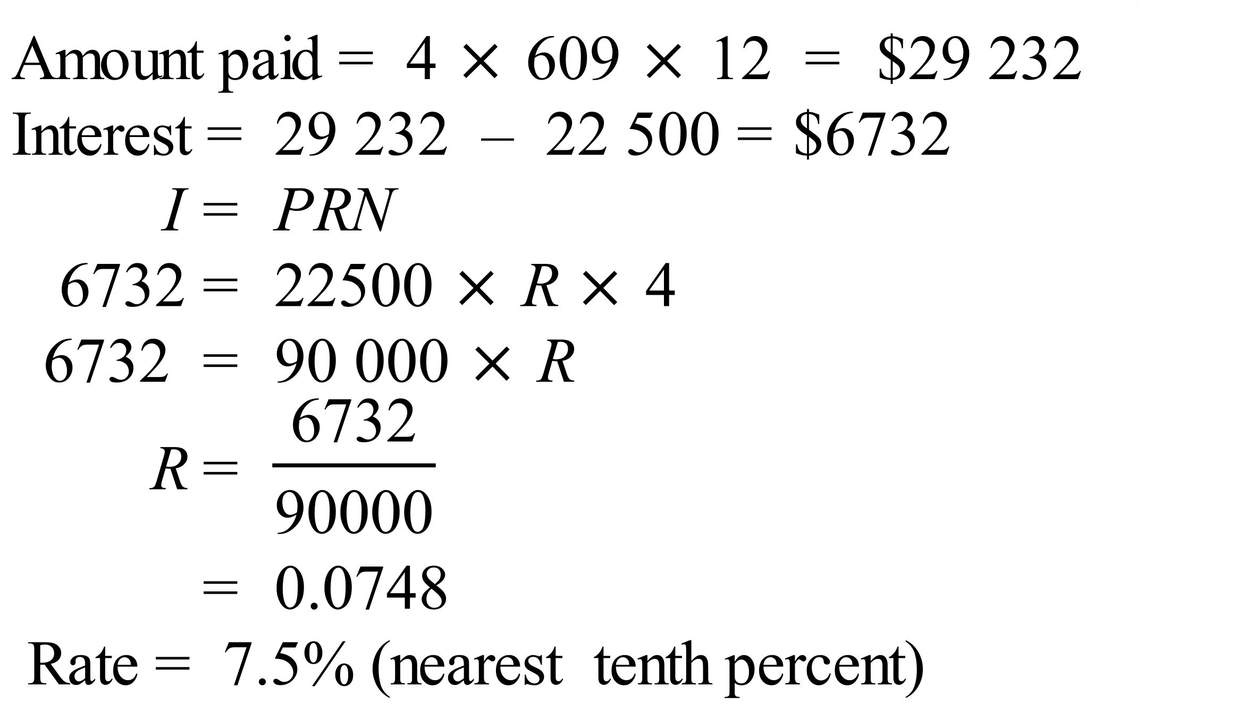 | D
 | 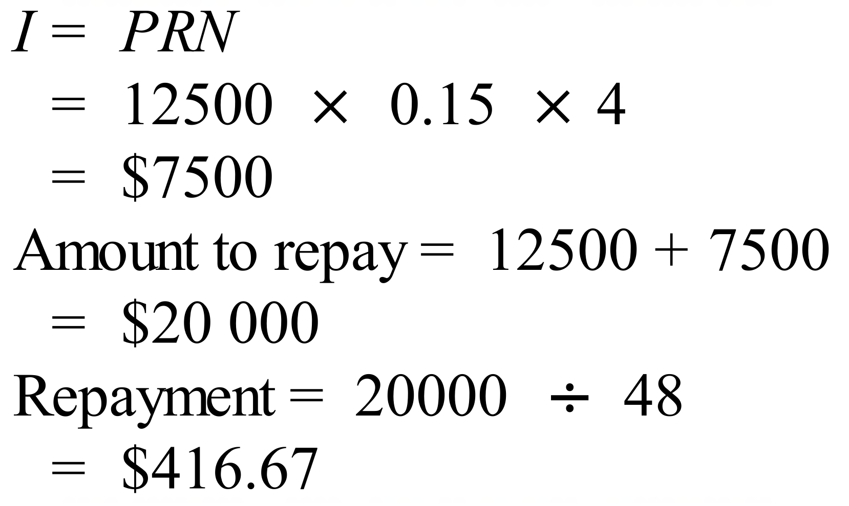 | B
 | 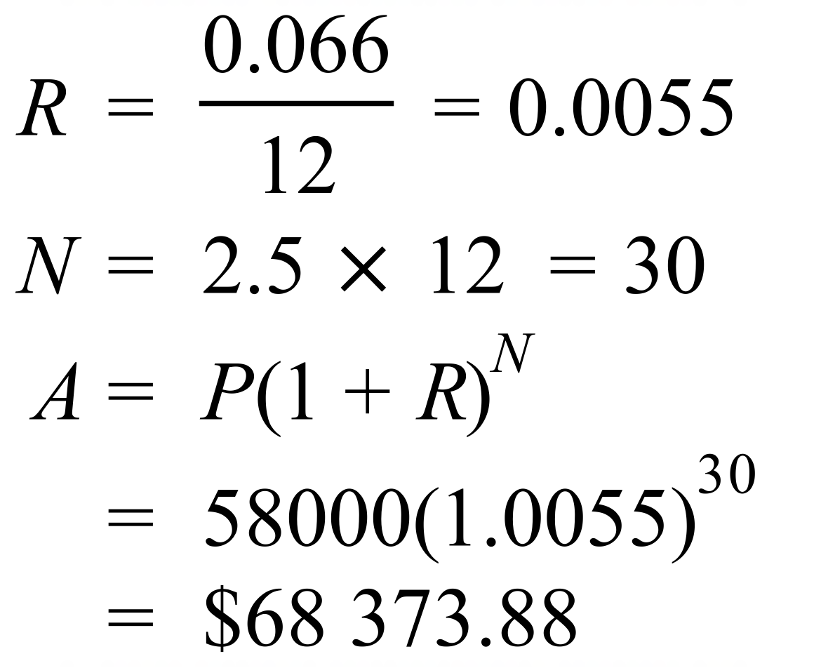 | A
 | 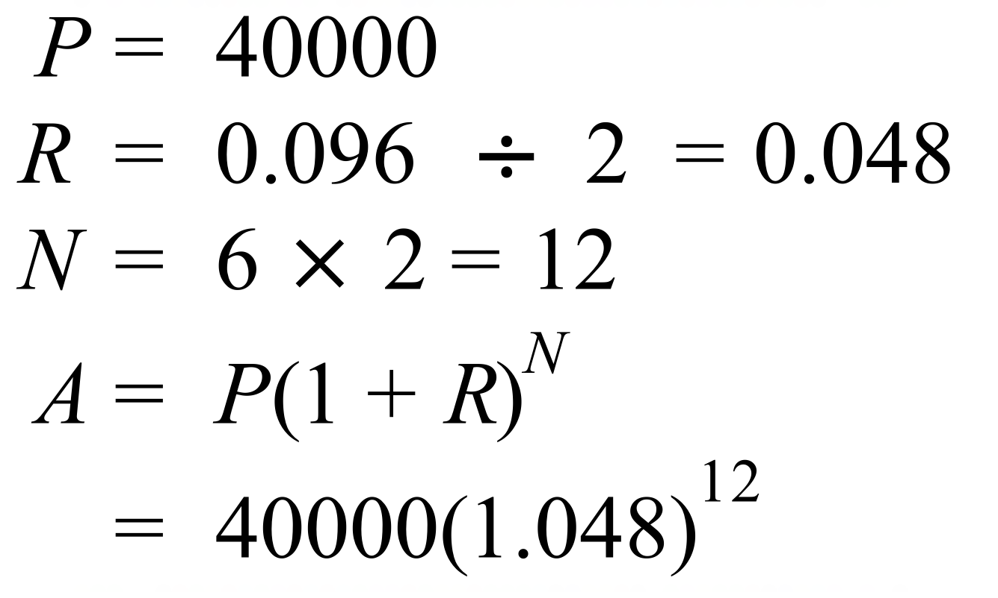 | C
 | 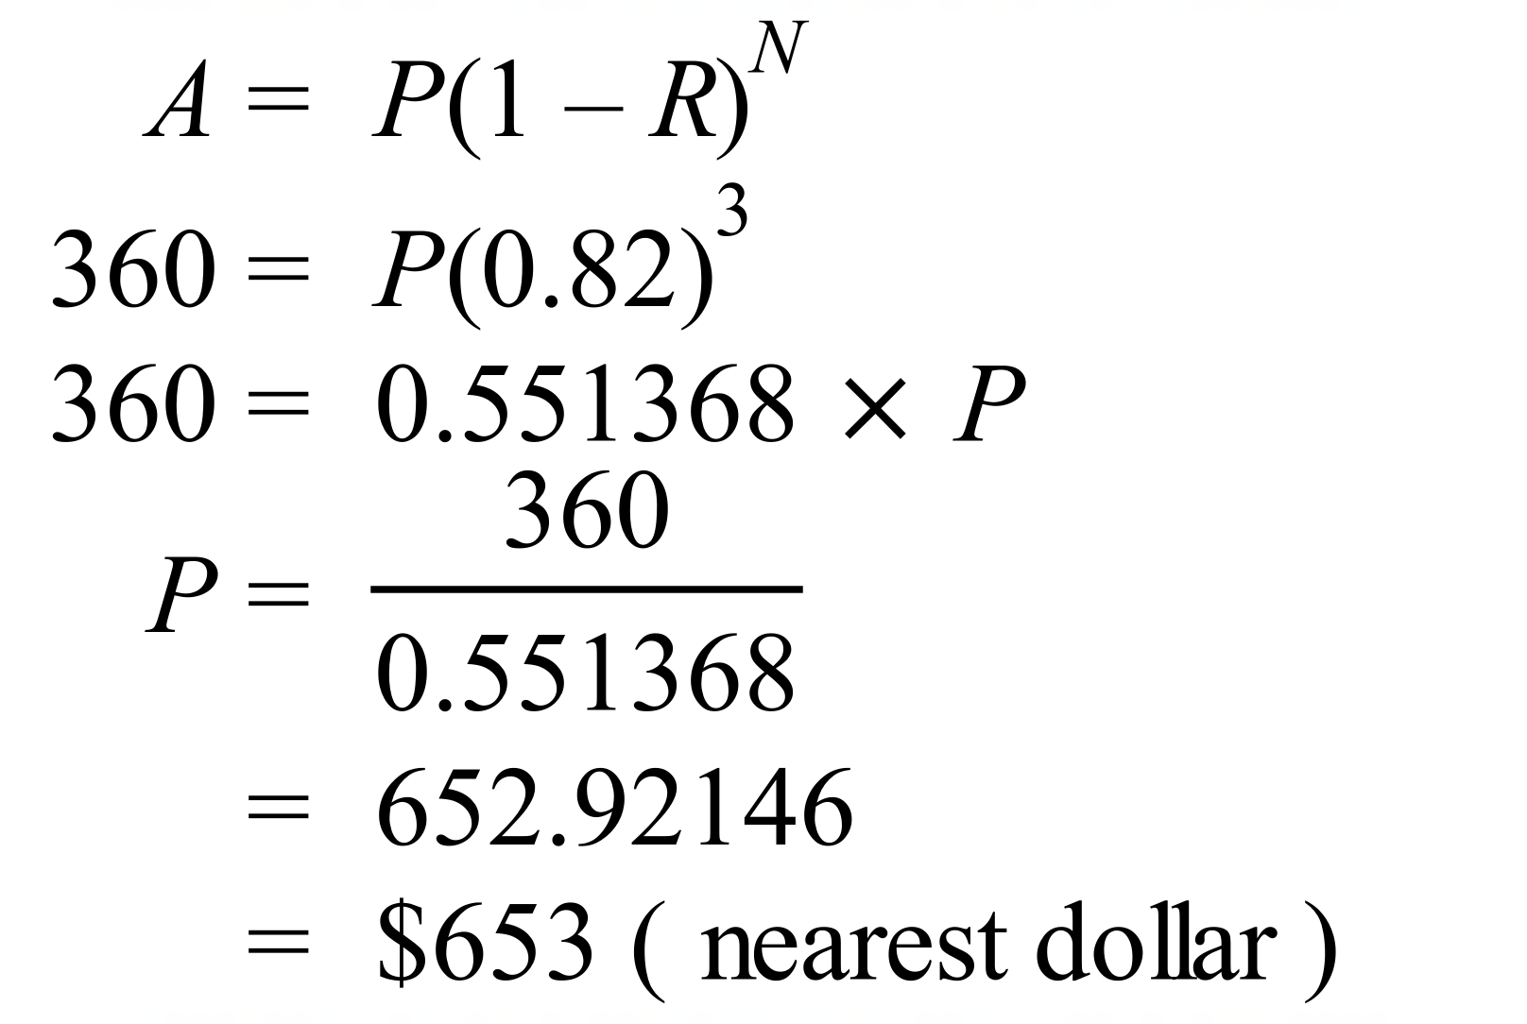 | D
 | 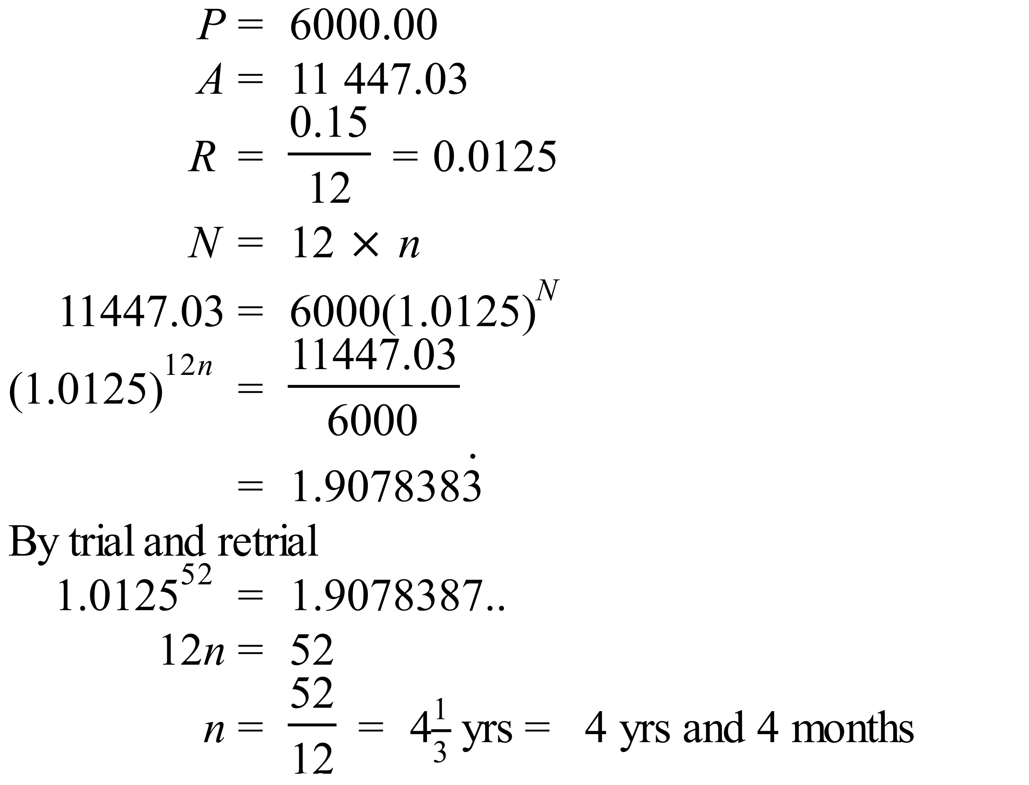 | B

School Name
Mathematics 2017
Multiple Choice Answer Sheet
Financial Maths & Compound Interest
Name _____________________________________________
Completely fill the response oval representing the most correct answer.
1. A B C D
2. A B C D
3. A B C D
4. A B C D
5. A B C D
6. A B C D
7. A B C D
8. A B C D
9. A B C D
10. A B C D
11. A B C D
12. A B C D
13. A B C D
14. A B C D
15. A B C D

